Documentation
Grep Command

Print all lines containing the string Laner
Use grep command to print all lines containing the string lane
grep “lane” ‘GrepLab(1)’
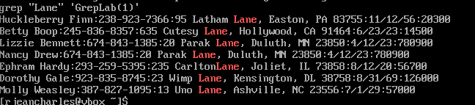
Breakdown Command
grep : Search for text patterns within a file
“lane” : the string pattern to look for
‘GrepLab(1)’ : The file name where to search

Print all lines where the person’s first name starts with H
Use grep command to Print all lines where the person’s first name starts with H
grep ^H “GrepLab(1)’
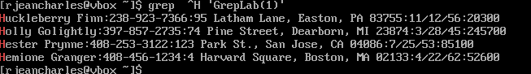
Breakdown Command
grep : A command uses to look for specific text patterns
^ : Indicate to search the beginning of a line
H : Specific character to look for
‘GrepLab(1)’ : The file name that contains the information.

Print all lines ending in three zeros (000)
Use grep command to Print all lines ending in three zeros (000)
grep 000$ ‘GrepLab(1)’
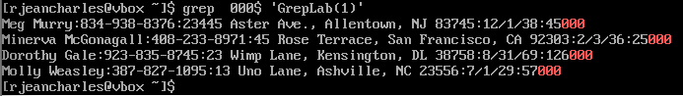
Breakdown Command
grep : Command use to print or look for pattern within a file
000 : The three 0 I am looking for in a line
$ : It represents the end of the line
‘GrepLab(1)’ : The file target that contains the information

Print all lines that don’t contain 408
Use grep command to Print all lines that don’t contain 408
grep -v “408” ‘GrepLab(1)’
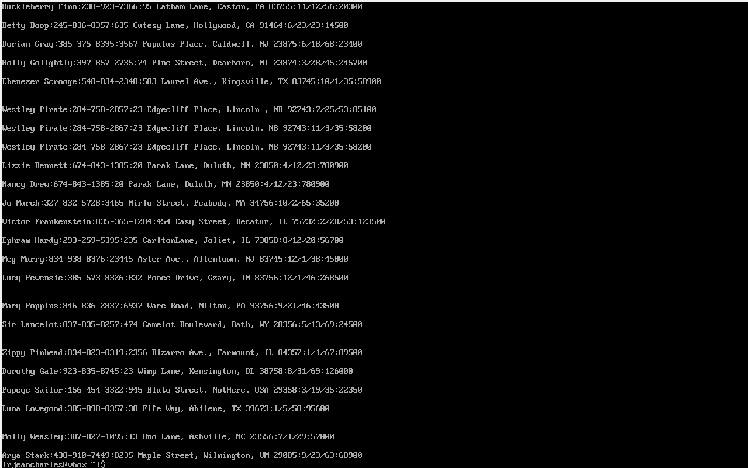
Breakdown Command
grep : Command that used to print or search for specific pattern
-v : Indicates grep command to hide the line that contains this pattern.
“408” : The specific pattern to search for
‘GrepLab(1)’ : File name that being searched information in

Print all lines where birthdays are in the year 1935 (be careful of the
date format! it’s MM/DD/YY)
Use grep command to print all lines where birthdays are in the year 1935 (be careful of the
date format! It’s MM/DD/YY
grep ‘/35’ ‘GrepLab(1)’
grep ‘/35’ ‘GrepLab(1)’ it works just because i start the strings with / that's why there isn’t any number starting with / only the birthdays. It based on the date format provided in the data.
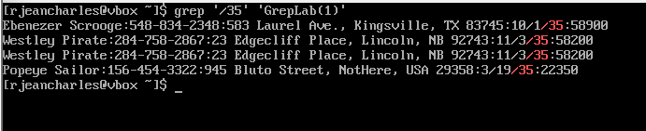
Breakdown Command
grep : command used to print or search for a pattern within a file
‘/35’ : the specific string to look for based on the date format
‘GrepLab(1)’ : The file name that is being searched

Print all lines where the phone number is in an area code that starts
with an 8

Use grep to Print all lines where the phone number is in an area code that starts
with an 8
grep -E “:[8][0-9]{2}-[0-9]{3}-[0-9]{4}” ‘GrepLab(1)’
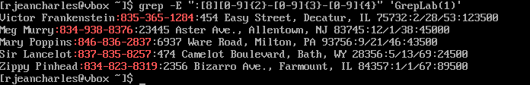
Breakdown Command
grep : Command to search for or to print a specific text pattern
-E : Allows to use other characters such as {} without using a lot of backslashes
“:[8][0-9]{2}-[0-9]{3}-[0-9]{4}” : Format number as specific strings
: The line started with a column
[8] : The first digit is supposed to start with 8
[0-9]{2} : two digits following the 8 from any number between 0 and 9
-[0-9]{3} : hyphen following by three digits from any number between 0 and 9
-[0-9]{4} : hyphen following by four digits that can be any number between 0 and 9
‘GrepLab(1)’ : The file name that contains the information

Print all lines containing an uppercase letter, followed by 4 lowercase
letters, a space and one uppercase letter.
Use grep command to print all lines containing an uppercase letter, followed by 4 lowercase letters, a space and one uppercase letter
grep -E ‘[A-Z][a-z]{4} [A-Z]’ ‘GrepLab’
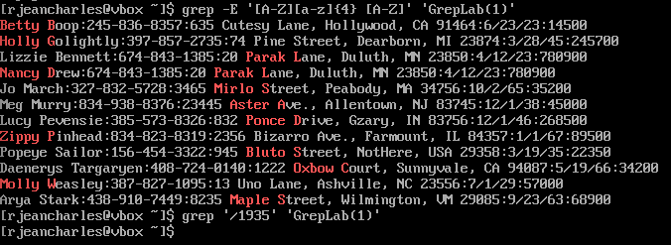
Breakdown Command
grep : Command use to search for specific text pattern
-E : Allow to use {} without using a lot of backslashes
‘[A-Z][a-z]{4} [A-Z]’ : Format letter or word as specific string character
[A-Z] : Uppercase letter
[a-z]{4} : 4 lowercase letters following the uppercase letter
: Space to allow the beginning of new word
[A-Z] : Another uppercase letter that start new word following the space
‘GrepLab’ : File name that is being searched

Print lines where the address begins with a two- or three-digit number
(so this would be 12 main st or 123 main street but not 1234 main
street).
Use grep command to print lines where the address begins with a two- or three-digit number (so this would be 12 main st or 123 main street but not 1234 main
street).
grep -E “:[0-9]{2,3} [A-Za-z]” ‘GrepLab(1)’
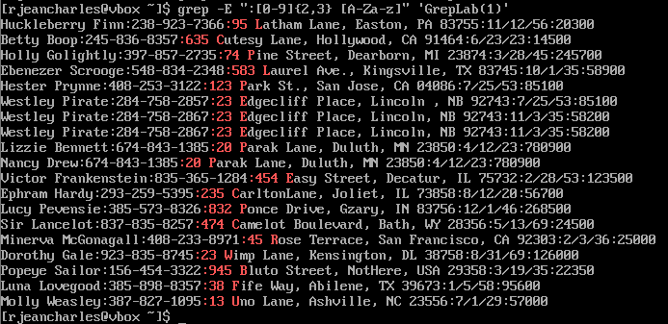

Breakdown Command
grep : Command that allows to search for specific text character or print within a file
-E : Allow to use other characters such as {} without repetition of backslashes
“:[0-9]{2,3} [A-Za-z]” : Specific address format as string
: Start with a column
[0-9]{2,3} : Indicate to search for any digit that appears 2 or 3 times.
: Space separate street number from street name
[A-Za-z] : Indicate to search for any letter whether it’s uppercase or lower following the digits
‘GrepLab(1)’ : File name containing information and is being searched

Print lines where the person lives in Mass or Illinois
Use grep command to Print lines where the person lives in Mass or Illinois
grep -E “, (MA|IL) [0-9]{5} ‘GrepLab(1)’
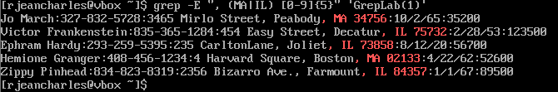
Breakdown Command
grep : Command use to search for or to print specific text pattern
-E : Allow to use {} without adding a lot of backslahes
, : A comma followed by space
(MA|IL): It indicates Massachusetts or Illinois
: Space before the ZIP code
[0-9]{5}: Indicates that it supposed to match 5 digits
‘GrepLab(1)’: The file that contains information

Print lines containing the addresses that aren’t on a street (You might
see St as shorthand for street)
Use grep command to Print lines containing the addresses that aren’t on a street (You might see St as shorthand for street)
grep -Ev “ Street | St\.?\b” ‘GrepLab(1)’
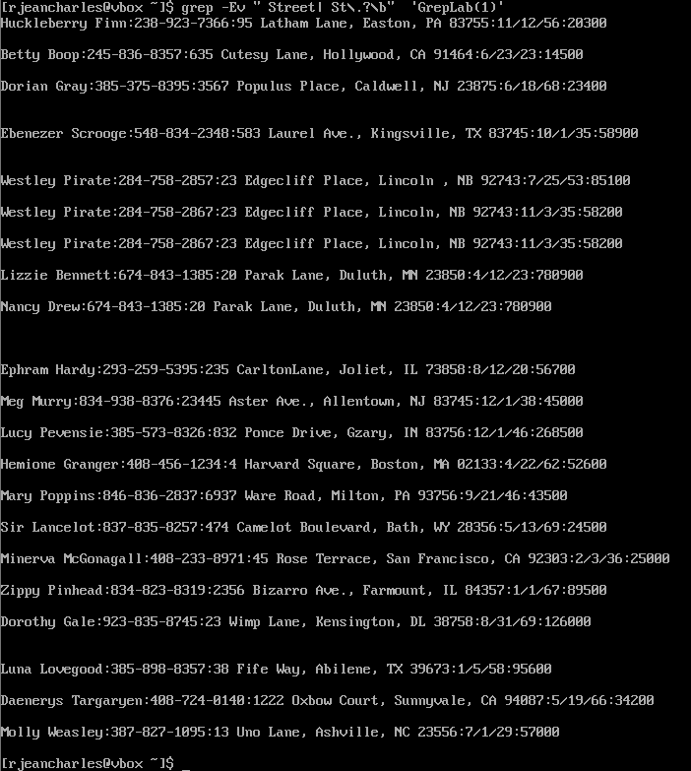

Breakdown Command
grep : command used to print or search for specific text pattern
-Ev : combination of -E allowing to use other type of characters and -v that indicates to hide lines that contain the pattern in question.
“ Street | St\.?\b” : the specific pattern being searched Street or St. as string
Street : The full word to search for
| : or operator looking for pattern that could match Street or St abbreviation
St : the letters St to search for as abbreviation
\.? : Period after the St letters that matches either the St or St. abbreviation
\ : Allow the dot to not refer to any or a specific character
. : without the slash the period will refers to any character
? : It indicates that St in the data might have a period or not. The period character is seen as an option now
\b : ensure the St abbreviation matches exactly St., it allows the St to appear as a complete word and not as a part of another word.
‘GrepLab(1)’ : The file name being searched

References
https://www.aholdengouveia.name/LinuxAdmin/Grep.html
https://www.redhat.com/en/blog/how-to-use-grep
https://www.gnu.org/software/grep/manual/grep.html
https://www.youtube.com/watch?v=Tc_jntovCM0
https://www.youtube.com/watch?v=dp-D9HNuVcM

